Grammar
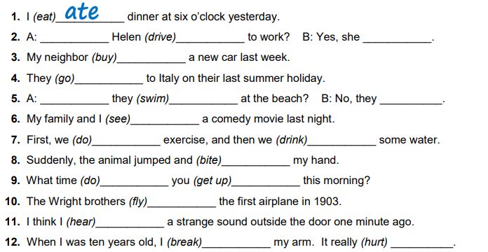
Fill in the space with the correct past tense verb. Some of them are questions in the past so they need DID.

Maths
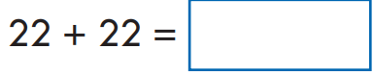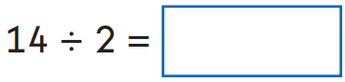
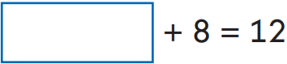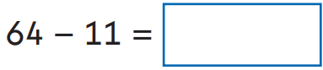
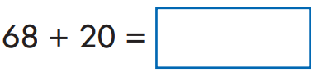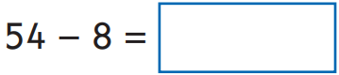
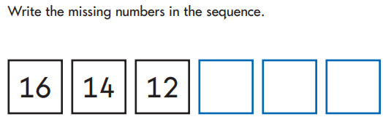

Please remember to read your book and practice your 2, 5 and 10 times tables.

