Homework Friday 15th March
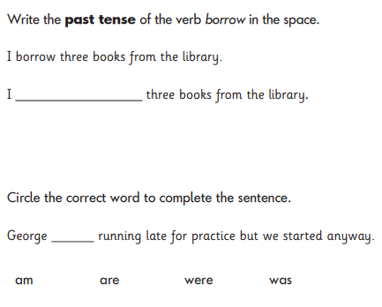
English:

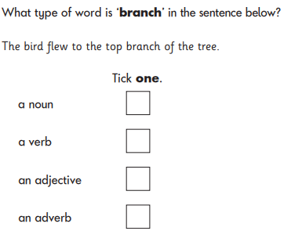

Maths Please go on google and search: Hit the Button - Quick fire maths practise for 6-11 year olds (topmarks.co.uk). Spend time working on these number skills:
- number bonds to 10 & 20
- X2, x5, x10
- halves
- doubles

