Friday 9th February 2024
Please work on your home learning projects over the break, and read.
English:
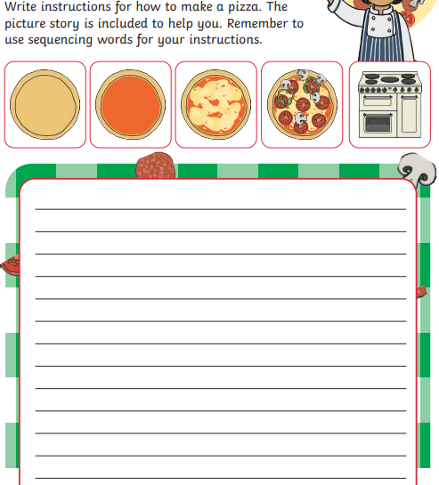
Maths:. Practice building and using an array.
