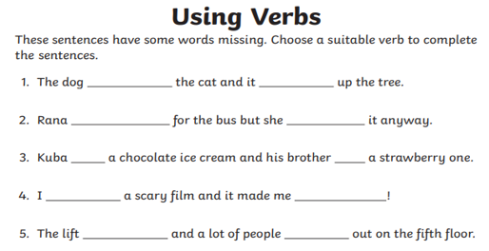

Challenge: Write your own sentences using the verbs felt, carried and started.
__________________________________________________________________________________________________________
___________________________________________________________________________________________________________________________
___________________________________________________________________________________________________________________________
___________________________________________________________________________________________________________________________
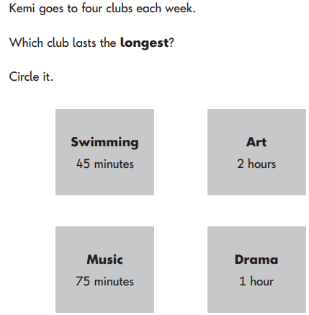
Maths
