Friday 9th February 2024
Please work on your home learning projects over the break, and read..
English:
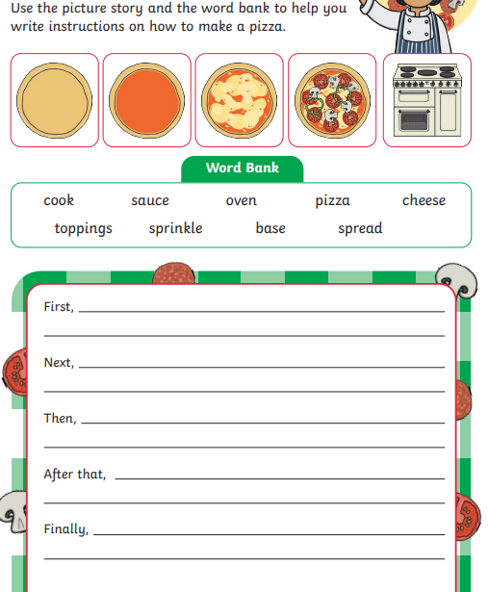
Maths: Practice building and using an array.
