Friday 9th February 2024
Please work on your home learning projects over the break.
English:
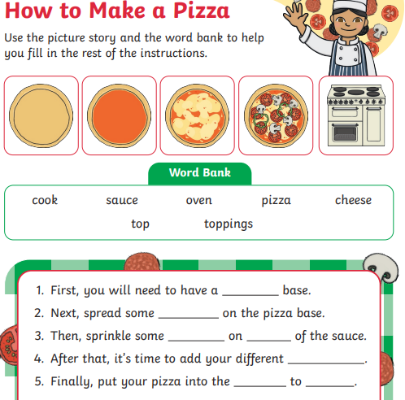
Maths:
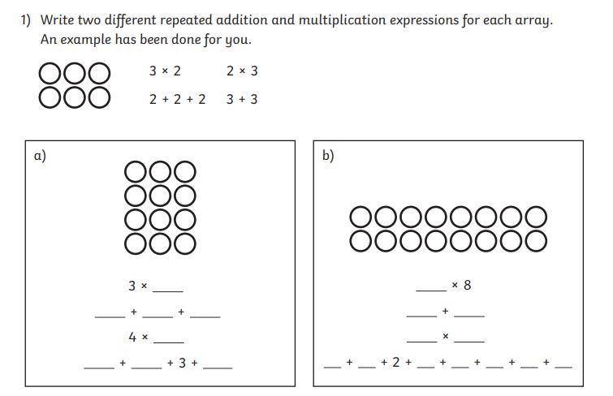
Reading: Please read with your child and sign their reading record.

