Friday 19th January 2024
Homework must be handed in on Wednesdays to be marked.
English:
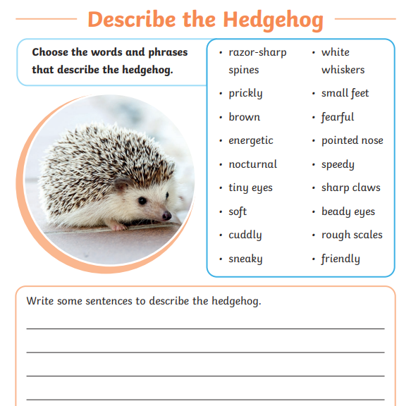
Maths:
