Friday 12th January 2024
Welcome back to Spring term!
Homework must be handed in on Wednesdays to be marked.
English: Write a sentence about each penguin picture using a determiner, adjectives, and noun (expanded noun phrase).
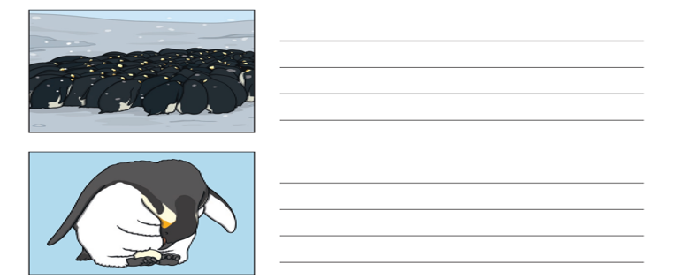
Maths:
