Friday 12th January 2024
Welcome back to Spring term!
Homework must be handed in on Wednesdays to be marked.
English:
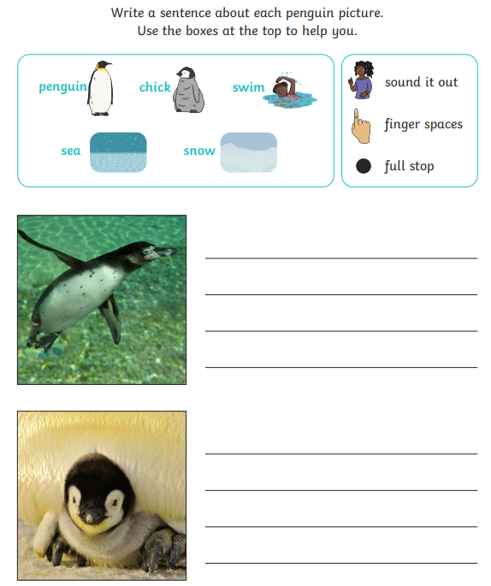
Maths:
