Friday 12th January 2024
Welcome back to Spring term!
Homework must be handed in on Wednesdays to be marked.
English: Write a sentence about this penguin picture, be creative, try to use an expanded noun phrase.
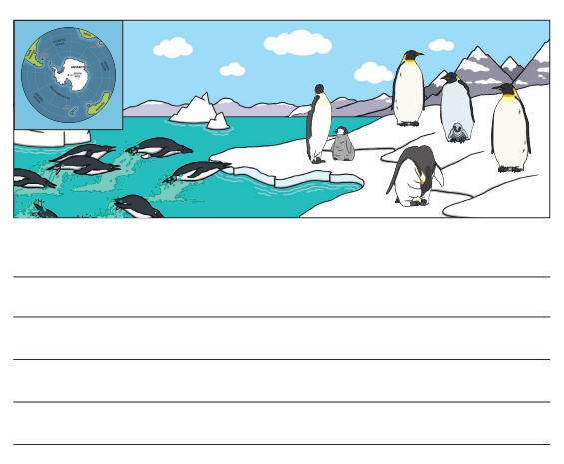
Maths:
