A Warm Welcome
to EYFS
2022
-
2023
Learning Together, Growing Together
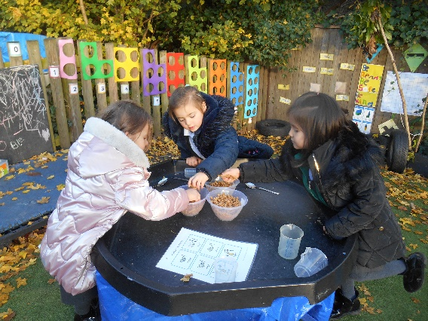
Mrs Davis Assistant Headteacher for EYFS
Nursery
and
Reception
Nursery:
Ms Marklew – Nursery Teacher, Ms Ozminnos, Ms Besime– EYFS Practitioners Ms Duran EYFS TA
Reception:
Ms Thomas Oak Class Teacher and Ms McAllister

Mrs Hickman - Ash Class Teacher and Ms Mehmet EYFS Practitioner
Miss Eraclis Birch Class Teacher and Miss Scarlett Jordan EYFS Practitioner
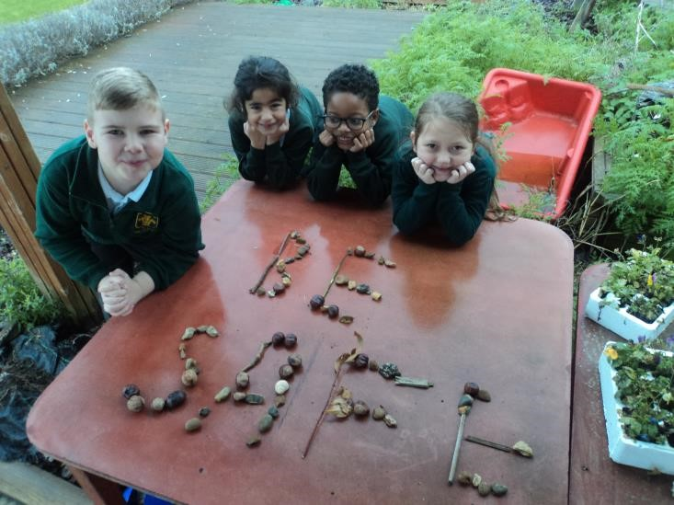
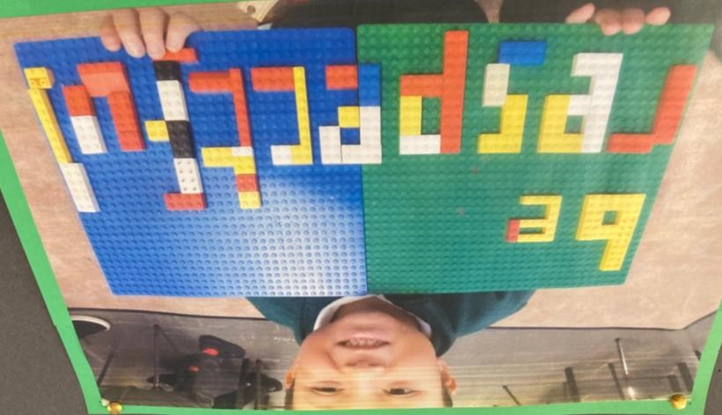
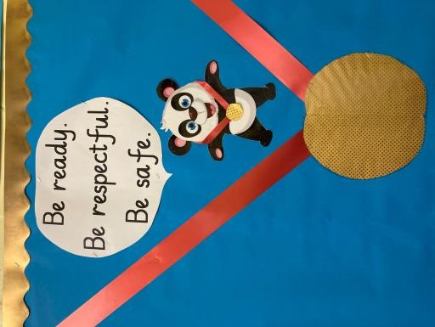
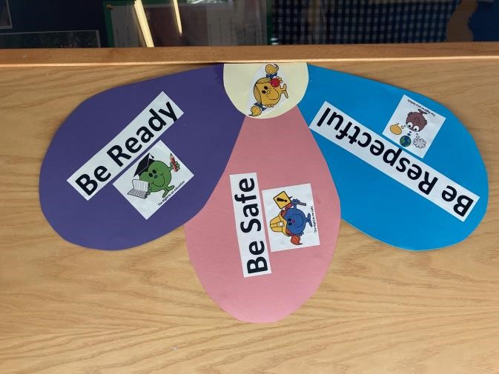
3
School Rules
Be
Ready
Be
Respectful
Be
Safe

Punctuality
In Nursery school starts at 8.30 - 8.45 for morning places and 12.15 - 3.15 for afternoon spaces. Please do not block the pathway if you are waiting for the gate to open and line up with your child behind the yellow line. Please do not press the buzzer unless you are late and all the children have already entered as we have children sensitive to the buzzer sound and become distressed.
In Reception School starts promptly at 8.50am and finishes at 3.15pm. If your child arrives late and the class has already entered, you will need to go to the office in the main school with your child to sign them in. We will not be able to let your child in The building as they will not be marked in our fire register . due to being late Once you have signed them in with the office you will then need to bring them back to The Woodlands.
Be Ready
Late children are sent to the main school after school and you may be charged for collecting them late.

Attendance
It is important that your child does not miss any teaching days as this seriously affects their learning and opportunities.
If your child is unwell please call the school office to inform them. Please call daily.
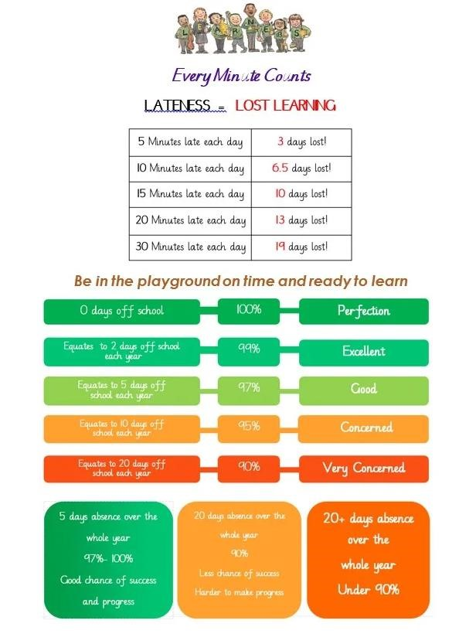
Attendance &
Punctuality
Uniform Children should come to school in full school uniform
Grey skirt or trousers and no leggings
Plain black shoes with black soles. NO LACES please.
Plimsolls for indoor PE and trainers for outdoor PE
Black or green hair bands
Be Ready
No jewellery. Only small ear studs allowed
PE kit (white/black shorts and white t-shirt)
On Tuesdays please make sure your child comes to school dressed in their PE kit as they have PE every Tuesday.
Appropriate hair styles
No nail varnish

Only 30 hour nursery children have lunchtime. You will need to bring a packed lunch if your child
attends our nursery for 30 hours provision.
Reception children will be
going to the dinner hall to have their lunch. If your child is struggling to eat our
lunches we will inform you and ask you to bring them a packed
lunch. Please look out for a slip inside their
book bag.
If your child is having a packed lunch this needs to be a healthy packed lunch. No sweets, fizzy drinks or
nut
products. No Nutella or chocolate spreads.
You
will need to pre order your child’s school dinner
choice if your child is in reception. This needs to be
completed every week
Lunchtime

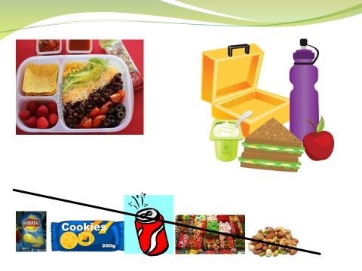

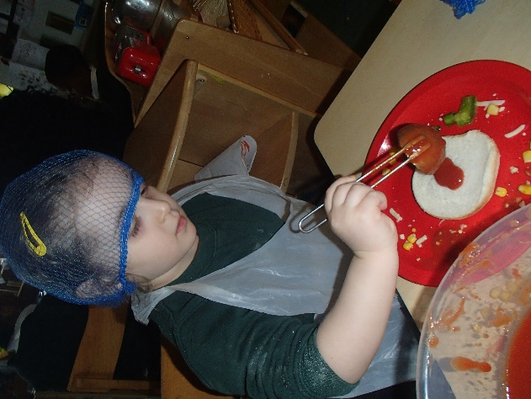
Homework
Please bring your child’s book bag to school every day. Reception children will receive a homework book with homework every Friday. Please return homework every Tuesday. A Microsoft teams login will be inside the front cover. Please download teams for various messages, information and occasional homework.
Be Ready
Nursery and reception children will receive a Bedtime story for you to read to them. This is changed once a week.
In addition to set homework there is an expectation that
Children read everyday and have their reading record signed and brought to school every day
We charge £5 if you have lost or damaged a book that is sent home.
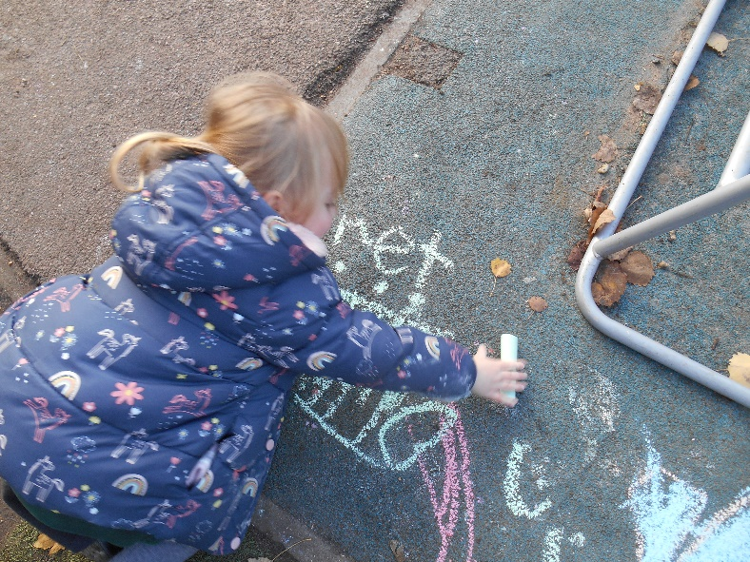
Your child will be bringing home a book to read with you at home when they begin to have an awareness of sounds. We assess the children every six weeks. If your child does not bring a book with words to read it means they are not ready for it. We will assess them and re – check throughout the year.
You will receive a home/ school diary with words and letter sounds in them. Please read with your child every day for ten minutes and practise learning their sounds and words.
Reading
In October you will be invited to attend a Letters and Sounds workshop for parents.
£5 multi activity voluntary contribution every term.
Working Together
The partnership between child, parents and school is crucial to your child’s success. Keep yourself informed through
-school website
Be Respectful
-newsletter and communication via email
-accessing parent consultations, Cafés and other events
If there are any concerns about learning please contact the class teacher in the first instance.

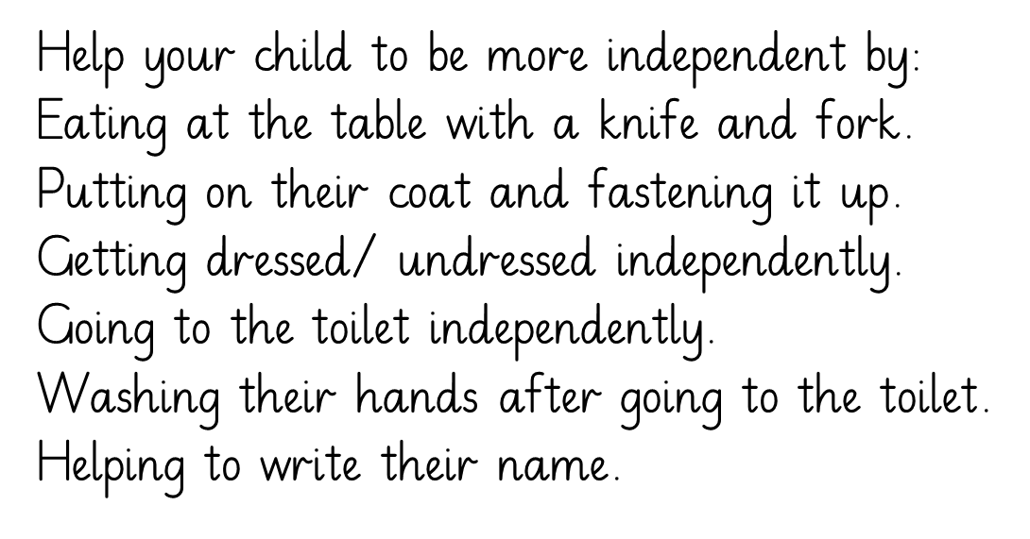
Helping your child
Medical needs – please let Mrs Dunlea know
If your child has a cold they can still come to school. If they have a temperature they should stay home. If they have diarrhoea they need to wait 48 hours before returning. Any Covid symptoms need to be reported to the office straight away.
Be Safe
Safeguarding -Please inform us if you are unable to collect your child and are requesting someone else comes to collect them. Please ensure the person coming to collect is given your password.
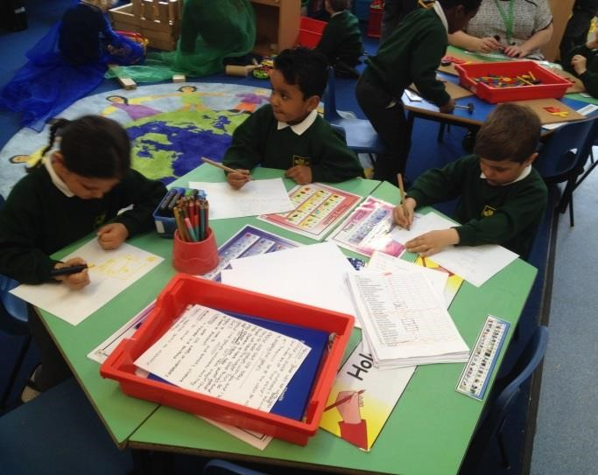
Bumps
If your child has an accident and bumps their head, it is not necessary to contact you
immediately. You will receive a ‘ Bumped Head Letter’ at home time. These letters serve an
important role as the class teachers in Reception are not with their classes at Lunchtimes,
and may not know to tell you. If we think the bump is more serious we will of course contact
you to inform you by phone.
What do they need to bring to school?
•
A book bag. This is available from our school shop.
•
A rucksack with a full change of clothes. Include socks and
underwear ( does not need to be uniform) with a pack of wipes.
This bag will stay in school
•
A water bottle
•
A waterproof coat.
Chn
in nursery and reception go outside even
when it is raining!
•
Wellington boots ( to be kept at school)
•
Come in PE kit every Tuesday ( already dressed)
- World Harvest - 12 October
- Beauty and the Beast Café – tbc
- Phonics and reading workshop with Mrs Davis for reception – date coming soon!
Dates
- National Tree Day - 2 December
- We invite parents to school every half term to attend our
Café’s
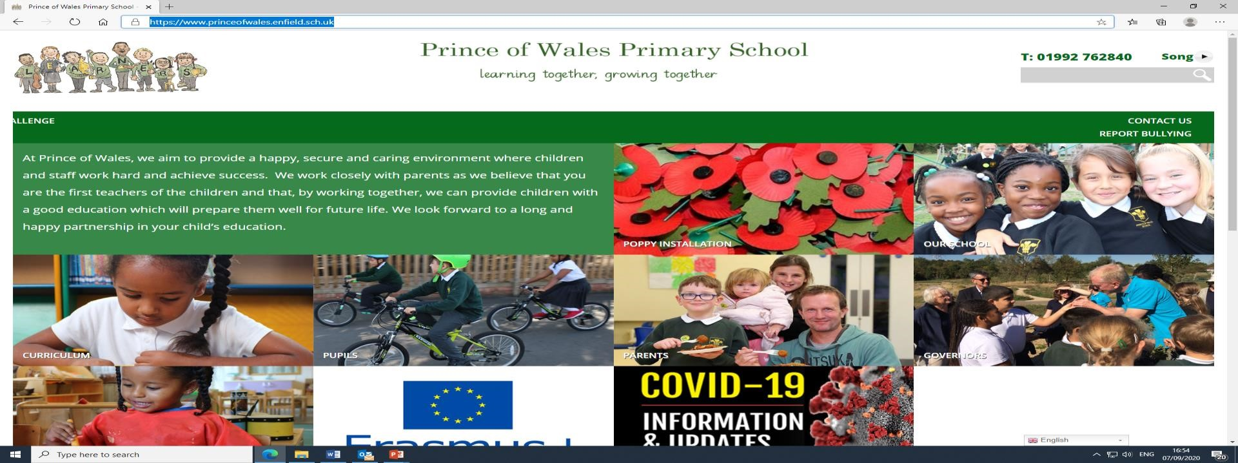
How to access our school website
https://www.princeofwales.enfield.sch.uk
/

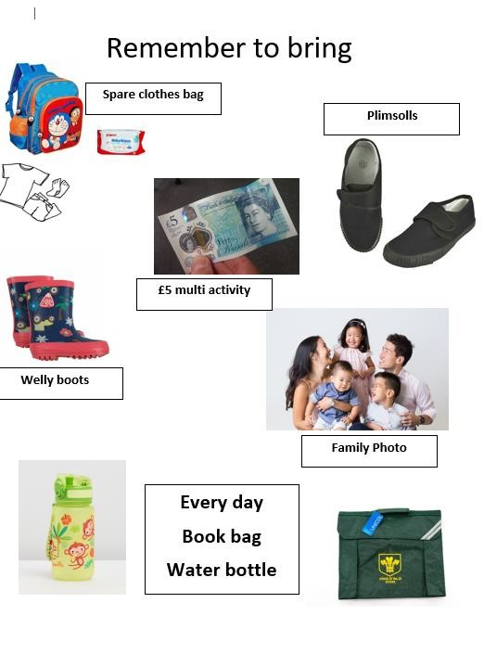
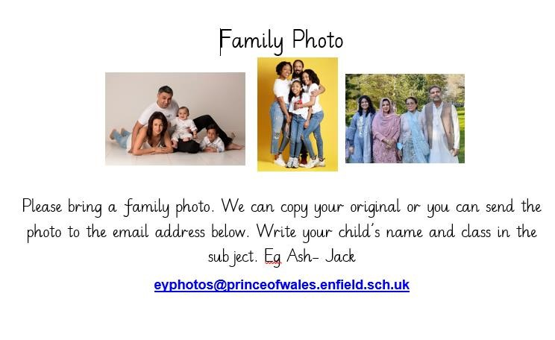

- Are there any questions?
Thank you for
attending our
information
session

