Answers for Day 3 and 4
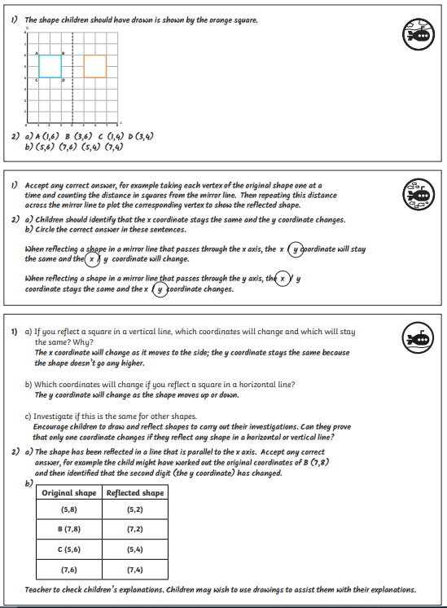
3 Coordinates for D is: (8,6); because point D needs to be in a straight line from point B/
Diagonal line from point A

