[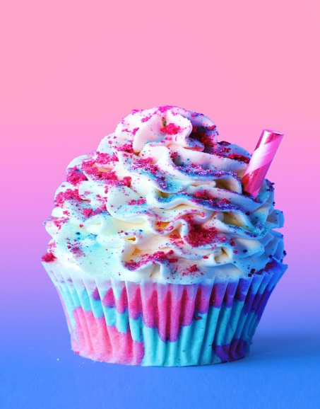](https://www.google.co.uk/url?sa=i&rct=j&q=&esrc=s&source=images&cd=&cad=rja&uact=8&ved=2ahUKEwinqcjpgvHbAhWHuxQKHRhACHoQjRx6BAgBEAU&url=https://www.tastemade.com/videos/unicorn-frappuccino-cupcakes&psig=AOvVaw2QfyGgkHjnt9w81SlGhuCH&ust=1530091858441405)

[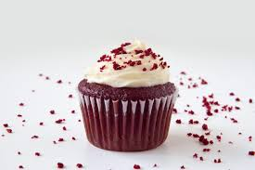](https://www.google.co.uk/url?sa=i&rct=j&q=&esrc=s&source=images&cd=&cad=rja&uact=8&ved=2ahUKEwierKnFg_HbAhXFbhQKHV6EAJUQjRx6BAgBEAU&url=https://www.littleswissbaker.com/vegan-red-velvet-cupcakes/&psig=AOvVaw2QfyGgkHjnt9w81SlGhuCH&ust=1530091858441405)[](https://www.google.co.uk/url?sa=i&rct=j&q=&esrc=s&source=images&cd=&cad=rja&uact=8&ved=2ahUKEwjLjbSlg_HbAhXM6xQKHTNVDFoQjRx6BAgBEAU&url=https://www.foodnetwork.com/recipes/food-network-kitchen/rainbow-cupcakes-3589733&psig=AOvVaw2QfyGgkHjnt9w81SlGhuCH&ust=1530091858441405)

[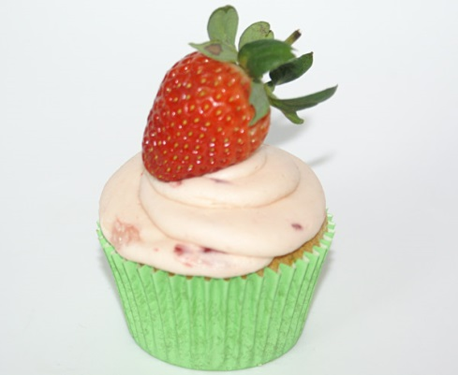](http://www.google.co.uk/url?sa=i&rct=j&q=&esrc=s&source=images&cd=&cad=rja&uact=8&ved=2ahUKEwjOzbLog_HbAhWMWxQKHfOoBCcQjRx6BAgBEAU&url=http://www.happy-cakes.co.uk/cupcakes/&psig=AOvVaw2QfyGgkHjnt9w81SlGhuCH&ust=1530091858441405)

[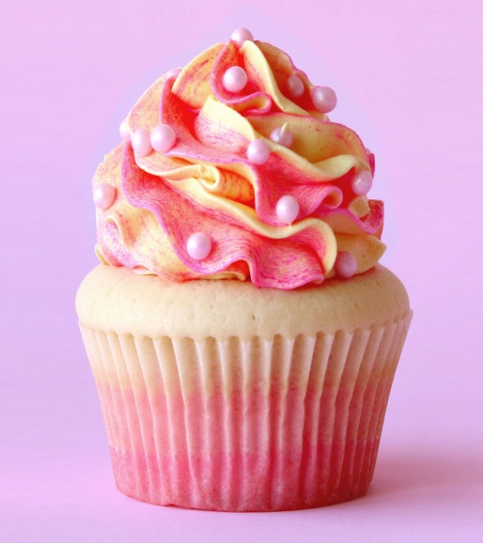](https://www.google.co.uk/url?sa=i&rct=j&q=&esrc=s&source=images&cd=&cad=rja&uact=8&ved=2ahUKEwjp7OjRgvHbAhUJlxQKHdTZDI8QjRx6BAgBEAU&url=https://www.tastemade.com/videos/rose-champagne-cupcakes&psig=AOvVaw2QfyGgkHjnt9w81SlGhuCH&ust=1530091858441405)[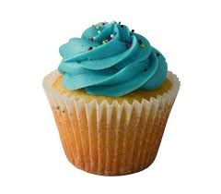](http://www.google.co.uk/url?sa=i&rct=j&q=&esrc=s&source=images&cd=&cad=rja&uact=8&ved=2ahUKEwjX0_WFhPHbAhUMNxQKHdyBAyAQjRx6BAgBEAU&url=http://www.socupcake.com/&psig=AOvVaw2QfyGgkHjnt9w81SlGhuCH&ust=1530091858441405)