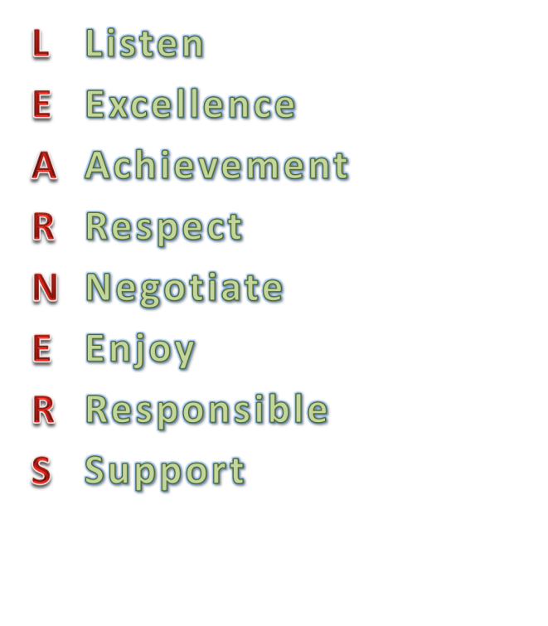

**Building works**

From Monday 17th September work will start on the extension of the KS1 block. The route from Salisbury Road into the playground will be slightly affected. We have asked that no deliveries and trucks use the road when families travel to and from school. If you have any concerns notify a member of staff.

Attendance w/c 10th September

#### KS1

#### 1C 96.7% 2R 95%

#### 1M 96.3% 2S 95%

#### **1N 97.3%**

#### KS2

#### 3D 95.9% 4A 99.3%** 5F 97.5%

#### 3F 94.9 4K 95% % 6B 99.3%

#### 3W 96% 5G 95.7% 6H 95.5%

#### Whole School Attendance — 96.2%

#### School Target 95%

#### Well done to for best attendance this week.

**Traffic in Salisbury Road**

I have seen how busy Salisbury Road gets when dropping off and collecting children. If possible please walk to school. For those who drive I ask for patience and calm when negotiating limited spaces and to respect the yellow lines and school exits.

Please remember that you are expected to be a positive role model to the children you bring to school.

**Dates**

05.11 Staff Inset (*not* 05.10 as stated last week)

18.11 Y1 to Y5 Meet the teachers

20.11 Y6 Meet the teachers and secondary school transfer

17.10 3 Form Entry Consultations 2.30pm and 6pm

**Lining up in KS1**

It is very busy around the Year 1 and Year 2 lines in the morning. We are demarcating where each class has to line up. Please can we ask for your cooperation in standing away from the lines so that children can see when they have to go inside the school.

**Prince of Wales values**

The following values have been selected to remind our children of the behaviour we expect to see at Prince of Wales:

We will use these words to support children in their learning. Please use them at home where possible. This week we focussed on listening. Each class teacher nominated a child who exemplified being a good listener and communicator. They were given a special certificate in assembly in front of the whole school

The next ‘Word of the Week’ is supportive.

**Bikes and scooters**

Please remind your child that bikes and scooters are not to be used on the playground.

Dear Parents, Carers, Governors and Friends,

I found the meetings held on Tuesday with you very constructive. Over 100 of you were able to join me and give me further insight into Prince of Wales. I welcome your comments on current strengths and areas you feel need developing. I will publish these on the school’s website and inform you through the weekly newsletters when any of these issues have been addressed.

Mr Jan M Bless

Headteacher

PRINCE OF WALES  
PRIMARY SCHOOL & CHILDREN’S CENTRE

**NEWSLETTER 14th September 2012**

