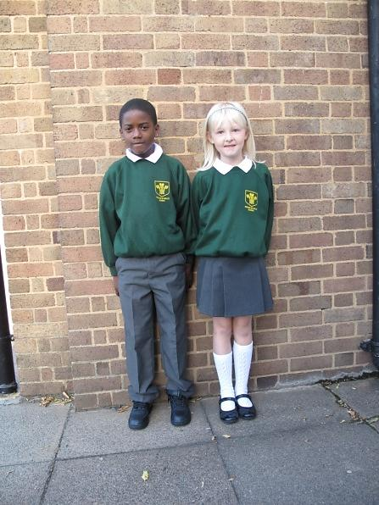

Dear Parents, Carers, Governors and Friends,

Welcome to the start of the new school year. I hope you had an enjoyable break over the holiday period and managed to enjoy the successful London Olympics!

I hoped the new Year 3 classrooms would have been completed as well as a smart staff car park. However, we are experiencing delays that will last another few weeks. More building works is planned to extend the KS1 corridor to commence in mid-September. We will keep you informed of any changes that affect where your child lines up.

Welcome to many new members of staff:

**Teaching Staff:** Zoe Lewis, Eleanor Matthews, Paul Underwood and Dhanny Deeno

**SEN and Inclusion staff:** Laura Clemenets and Val Russell

**Reading Recovery Teacher:** Bina Thambiah

**Support staff:** Irene Bistan, Elena Kombou, Anna Lyons, Christina Richards, Raveena Shivnaini, Emma Tsenti, Wendy Dakin, Sena Alim and Delia Ryde Lane

**Children’s Centre:** Ayse Moroglu, Laura Kelleher, Wioletta Wolinoskwa and Christine Christou

We are very pleased to have all our new staff starters as part of our team and hope they will  
enjoy being with us at Prince of Wales.

Mr. Jan M Bless

Headteacher

**School Uniform**

The children have returned keen and enthusiastic, and are looking very smart in their uniforms. Thank you for your support with this. We want children to be proud of being part of Prince of Wales and feel a genuine sense of belonging. Putting on their uniform indicates that your child is ready to learn. We would appreciate your continuing commitment to ensuring children take pride in their appearance and come to school in full uniform please.

LONDON BOROUGH OF ENFIELD  
PRINCE OF WALES  
PRIMARY SCHOOL & CHILDREN’S CENTRE

7th September 2012

Dairy Dates:

Tuesday 11.09 9am – 10am, 2pm – 3pm or 6pm – 7 pm Meet Mr. Bless

Tuesday 18.09 see letter for individual class times Parents’ Information Evening and Y6 secondary transfer

Tuesday 25.09 9am – 12pm Class photos

Monday 05.10 School closed all day Staff Inset

Gold Medal Learners

We believe our children are all GOLD medal learners.

Each day they start on Gold and when they remain there by the end of the day they will achieve a tick on a chart. When these accumulate they will result in many types of awards. All we ask is that they:

1. *Come to school every day and on time*
2. *Wear their school uniform*
3. *Follow school rules*
4. *Do their best*

Each day is a fresh start for all. What will children do different to make things even better than yesterday?

“Insert Pull Quote Here. Delete Box If Not In Use.”